Aquia Harbour Volunteer
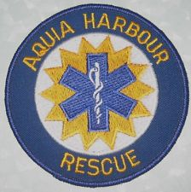
Rescue Squad
Cake
&
Refreshments
Open House
Fi First Aid teaching stations

teachstations

Firetruck Tour

Ambulance Tour

Celebrating EMS Week 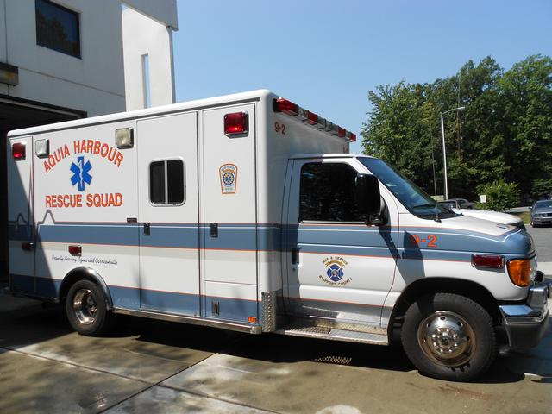

Sunday, May 15th 2016
1pm – 3pm
1001 Washington Drive

